# 5th Compendium of Inspiring Practices on Urban-Rural Linkages

**Special Edition on Intermediary Cities**

**Case Study Template**

The purpose of this template is to collect experiences on how intermediary cities are contributing effective interaction between urban and rural communities as well as between human settlements and nature, in the context of the UN-Habitat Guiding Principles on Urban-Rural Linkages[1]

UN-Habitat invites contributors to share case studies related to strengthening urban-rural linkages, particularly fostering the intermediary role of cities.

*UN-Habitat and OECD define Intermediary cities as small and medium-sized cities that play an intermediation role by connecting urban and rural areas.* [[*They act as hubs for the provision of goods and services and the structuring of urban-rural linkages, thereby providing a conducive environment for job creation and income diversification (*](https://unhabitat.org/news/07-jul-2021/why-local-why-now-strengthening-intermediary-cities-to-achieve-the-sdgs)](https://unhabitat.org/news/07-jul-2021/why-local-why-now-strengthening-intermediary-cities-to-achieve-the-sdgs)*OECD/UN-Habitat (2022)*

|  |
| --- |
| This open call for case studies can be submitted via two options:   1. Microsoft Forms (online), accessible [here](https://forms.office.com/Pages/ResponsePage.aspx?id=2zWeD09UYE-9zF6kFubccLDCuqy0U0ROqhGRCmWjCHtUN1hCVTVIQUFJMzQzOFcwSlhXTVZXTFJYTS4u) 2. Using this Microsoft Word template and sending via email to [unhabitat-url@un.org](mailto:unhabitat-url@un.org). |

**Notes**:

* The guiding questions in this template are designed to help the author to structure the case study in a way that ensures all relevant information is captured and will fit the outline of the Compendium.
* When filling the template, please refer to the publication <https://unhabitat.org/urban-rural-linkages-guiding-principles> and a Summary (<https://urbanpolicyplatform.org/wp-content/uploads/2021/10/Summary-of-Urban-Rural-Linkages-Guiding.pdf>).
* Please also refer to the **definition** of intermediary cities above to ensure the case study’s scope is an intermediary city or a group of intermediary cities.

**Summary**

|  |  |
| --- | --- |
| Case Study **Author (s)** | Name (s): |
| Organization (s): |
| Contact Details (Email address): |
| **Title** of Intervention |  |
| **Main Purpose** of the intervention | Add brief description on the objective of the intervention?  (Max 80 words) |
| **Partner(s)** *[if any]* |  |
| **Category** of Intervention | ☐ Project  ☐ Spatial Plan  ☐ Policy  ☐ Law/ Legal Instrument  ☐ Strategy  ☐ Program  ☐ Toolkit  ☐ Other. *If other, please describe in the box below:* |
|  |
| **Location** *(City/Local Area; Country)* |  |
| **Start** and **end** date *(or planned end date)* |  |
| **Status** (*select one box*) | ☐ Planned  ☐ Ongoing  ☐ Completed  ☐ Incomplete |
| **Link** to Sustainable Development Goals (SDGs)  *[Select all that apply]* | ☐SDG 1- No Poverty.  ☐SDG 2- Zero Hunger  ☐SDG 3- Good Health and Well-being  ☐SDG 4- Quality Education  ☐SDG 5- Gender Equality  ☐SDG6- Clean Water and Sanitation  ☐SDG 7- Affordable and Clean Energy  ☐SDG 8- Decent Work and Economic Growth  ☐SDG 9- Industry, Innovation, and Infrastructure.  ☐SDG 10- Reduced Inequality  ☐SDG 11- Sustainable Cities and Communities  ☐SDG 12- Responsible Consumption and Production  ☐SDG 13- Climate Action  ☐SDG 14- Life Below Water  ☐SDG 15- Life on Land  ☐SDG 16- Peace and Justice Strong Institutions  ☐SDG 17- Partnerships to Achieve the Goal  ☐ None |

**Intervention Details**

|  |  |
| --- | --- |
| Background and Context *(Max 400 words)* | Please provide a brief social-cultural, environment, economic background, the locational and functional context of the intermediary city |
| Purpose of Intervention *(Max 200 words)* | * What were/are the challenges and/or opportunities that necessitate the intervention. * What was/is the main objective (s) of the intervention in relation to the challenges/opportunities? |
| Implementation Process *(Max 800 words)* | Please describe the implementation process   * Which resources were/will be used? Human, financial, technical * What approaches were/will be used? * What tools and methodologies were/will be adopted? * Which partners and stakeholders were/will be involved and how were they involved? |
| Outcomes *(max 400 words)* | The fundamental guiding question is, what changed?   * What was the impact of the intervention? (*or expected accomplishment, if the project is yet to be implemented)*   + Who were the beneficiaries? (e.g Government, city, community, school)   + How many people benefitted, and how did they benefit?   + What monitoring mechanisms have been put in place to follow up, review progress and results? |
| How will/does the intervention contribute to strengthening urban-rural linkages in the intermediary city, and overall for the region or country? *(Max 100 words)* | How does the intervention enhance or impact the flows of people, goods and services, opportunities, across the urban-rural continuum? |
| Challenges and lessons *(In point form)* | What are some of the challenges faced in the implementation of the intervention? What lessons can be drawn from the intervention? |
| Replicability and sustainability *(Max 200 words)* | * How can the intervention or parts of it be applied in other contexts? * What strategies have been put in place to expand, continue or rephase the intervention? Either in the same context or in another context. |
| Beneficiary voices | Please add quotes or messages from beneficiaries if available. |
| Visual materials | * Please provide up to 3 high resolution images/infographic/maps/other visual materials. * Please ensure to include a caption and credit/copyright for these materials. * Please send these materials separately to maintain their quality. Email: [unhabitat-url@un.org](mailto:unhabitat-url@un.org) * You can also share additional links to the intervention (videos, websites etc) |

**Relevance and Application of the Guiding Principles on Urban-Rural Linkages**

In the table below, please select the principles that relate to your intervention and briefly describe how.

\**Please note that not all guiding principles need to be relevant to the intervention.*

|  |  |  |
| --- | --- | --- |
| **Guiding Principle** | **Relevance to intervention** | **Description (one or two sentences on how the intervention relates to the Guiding Principle)** |
| **1. Locally Grounded Interventions** | ☐ Very Relevant  ☐ Somewhat Relevant  ☐ Less Relevant  ☐ Not Relevant |  |
| **2. Integrated Governance** | ☐ Very Relevant  ☐ Somewhat Relevant  ☐ Less Relevant  ☐ Not Relevant |  |
| **3. Functional and Spatial**  **Systems-Based Approaches** | ☐ Very Relevant  ☐ Somewhat Relevant  ☐ Less Relevant  ☐ Not Relevant |  |
| **4. Financially Inclusive** | ☐ Very Relevant  ☐ Somewhat Relevant  ☐ Less Relevant  ☐ Not Relevant |  |
| **5. Balanced Partnership** | ☐ Very Relevant  ☐ Somewhat Relevant  ☐ Less Relevant  ☐ Not Relevant |  |
| **6. Human Rights-Based** | ☐ Very Relevant  ☐ Somewhat Relevant  ☐ Less Relevant  ☐ Not Relevant |  |
| **7. Do No Harm & Provide Social Protection** | ☐ Very Relevant  ☐ Somewhat Relevant  ☐ Less Relevant  ☐ Not Relevant |  |
| **8. Environmentally Sensitive** | ☐ Very Relevant  ☐ Somewhat Relevant  ☐ Less Relevant  ☐ Not Relevant |  |
| **9. Participatory Engagement** | ☐ Very Relevant  ☐ Somewhat Relevant  ☐ Less Relevant  ☐ Not Relevant |  |
| **10. Data Driven and Evidence-Based** | ☐ Very Relevant  ☐ Somewhat Relevant  ☐ Less Relevant  ☐ Not Relevant |  |

**Relevance of the Framework for Action to the Intervention**

* In the table below, please select the actions your intervention relates to and briefly describe how.
* *\*Please note that not all FfAs need to be relevant to the intervention.*

|  |  |  |
| --- | --- | --- |
| **Framework for Action** | **Relevance to intervention** | **Description (one or two sentences on how the intervention how relevant)** |
| **A. Governance, legislation, and capacity development** | ☐ Very Relevant  ☐ Somewhat Relevant  ☐ Less Relevant  ☐ Not Relevant |  |
| **B. Integrated planning across the urban-rural continuum** | ☐ Very Relevant  ☐ Somewhat Relevant  ☐ Less Relevant  ☐ Not Relevant |  |
| **C. Investment and finance for inclusive urban-rural development** | ☐ Very Relevant  ☐ Somewhat Relevant  ☐ Less Relevant  ☐ Not Relevant |  |
| **D. Empower people and communities** | ☐ Very Relevant  ☐ Somewhat Relevant  ☐ Less Relevant  ☐ Not Relevant |  |
| **E. Knowledge/data management for dynamic spatial flows of people, products, services, resources, and information** | ☐ Very Relevant  ☐ Somewhat Relevant  ☐ Less Relevant  ☐ Not Relevant |  |
| **F. Territorial economic development and employment** | ☐ Very Relevant  ☐ Somewhat Relevant  ☐ Less Relevant  ☐ Not Relevant |  |
| **G. Coherent approaches to social service provision** | ☐ Very Relevant  ☐ Somewhat Relevant  ☐ Less Relevant  ☐ Not Relevant |  |
| **H. Infrastructure, technology, and communication systems** | ☐ Very Relevant  ☐ Somewhat Relevant  ☐ Less Relevant  ☐ Not Relevant |  |
| **I. Integrated approaches for food security, nutrition, and public health** | ☐ Very Relevant  ☐ Somewhat Relevant  ☐ Less Relevant  ☐ Not Relevant |  |
| **J. Environmental impact and natural resource and land management** | ☐ Very Relevant  ☐ Somewhat Relevant  ☐ Less Relevant  ☐ Not Relevant |  |
| **K. Conflict and disaster** | ☐ Very Relevant  ☐ Somewhat Relevant  ☐ Less Relevant  ☐ Not Relevant |  |

**Annex 1: Summary of Urban-Rural Linkages Guiding Principles and Framework for Action**

**Guiding Principles:**

UN Habitat defines Urban Rural linkages as the as non-linear, diverse urban-rural **interactions and linkages across** **space within an urban-rural continuum**, including flows of people, goods, capital and information but also between sectors and activities such as agriculture, services and manufacturing. In general, they can be defined as a complex web of **connections between rural and urban dimensions[2]**. Through a consultation process with numerous stakeholders UN-Habitat has developed 10 guiding principles and 11 Framework of Action areas or thematic entry points. The collection of inspiring practices will help to raise awareness and build evidence encouraging others to apply the guiding principles through the framework of action to strengthen urban-rural linkages.

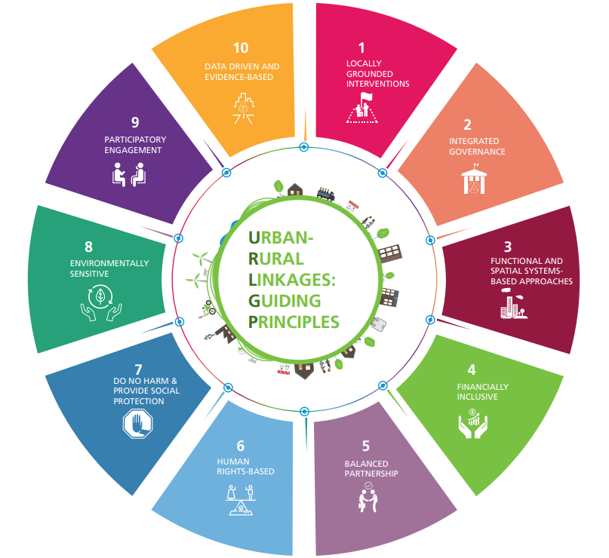

The 10 Guiding Principles are:

1. **Locally grounded interventions**: The local context matters a lot in making urban-rural linkages work and should inform and guide the translation of global agendas such as the 2030 Agenda for Sustainable Development (including the SDGs), the New Urban Agenda (NUA) and others.
2. **Integrated governance:** Strengthen governance mechanisms by incorporating urban-rural linkages into multisectoral, multi-level and multi-stakeholder governance.
3. **Functional Spatial Systems-based Approaches**: Use system-based approaches to promote integrative and inclusive urban, territorial and rural policy and planning to support the analysis of the flow of resources such as people, water, biodiversity and food.
4. **Financially Inclusive**: Secure and prioritize sustainable public and private investment to balance and strengthen urban-rural linkages. Where possible, adjust funding to meet objectives for integrated rural and urban economic, social and environmental development.
5. **Balanced partnership:** Foster partnerships, alliances and networks that link urban and rural actors and different sectors. Develop and harness capacities and skills across a wide range of stakeholders such as civil society, the private sector, and academic institutions through inclusive and participatory processes.
6. **Human rights-based:** Embed human rights-based approaches in all policy instruments and actions to ensure that development initiatives and processes do not negatively affect anyone’s human rights across the urban-rural continuum.
7. **Do no harm and provide social protection:** Strengthen urban-rural linkages to overcome conflict, recognize cultural diversity and reduce inequalities.
8. **Environmentally Sensitive**: the resources needed by the current population must be addressed without compromising the ability of future generations to meet future needs.
9. **Participatory Engagement:** Ensure meaningful participation by people, local institutions and communities across the urban-rural continuum.
10. **Data Driven and Evidence-based**: Establish or improve knowledge systems and fill data gaps so that there is evidence to support planning methods that will reinforce the urban-rural continuum and improve territorial cohesion.

**Framework for Action**

The Guiding Principles provide for flexible application by different levels of government, intergovernmental organizations, development partners and stakeholders from academia, research, civil society including grassroots organizations and the private sector. The **Framework for Action** addresses measures to create an enabling environment and measures related to **eleven sectoral and thematic entry points including:**

* **Governance, legislation, and capacity development**: assess capacity and needs for policy tools; enhance dialogue and cooperation across sectors and planning levels and convene new multi-level, multi-sector and multi-actor governance mechanisms and support inclusion of affected urban and rural populations.
* **Integrated planning across the urban-rural continuum:** Support localization of national planning; integrate urban-rural linkages and integrated territorial development in National Urban Policies and promote networks and associations of planners in different jurisdictions.
* **Investment and finance for inclusive urban-rural development:** Address and improve public and private finance and access to credit across the urban-rural continuum, focusing on small and intermediate towns and cities and integrated urban-rural territories. Strengthen financial intermediation services and enable ecosystem service provision in peri-urban and rural areas.
* **Empower people and communities:** Assess and support inclusive multi-actor participatory processes and partnerships; directly address and compensate for inequities across the urban-rural continuum in order to create balance and inclusion from informal and formal sectors**.**
* **Knowledge/data management for dynamic spatial flows of people, products, services and information:** Improve collection and management of spatially and gender disaggregated data and knowledge, including ensuring a balance between inclusion of the formal and informal sectors**.**
* **Territorial economic development and employment:** Coordinate urban and rural economic development to enhance synergies; harness the potential of small and medium size towns and apply innovations in participatory credit, finance and enterprise incubation schemes to create new jobs that improve territorial flows of products, services and information.
* **Coherent approaches to social service provision:** Identify needs and opportunities where stronger urban-rural linkages can impact more spatially and socially equitable service provision; pilot new urban-rural partnerships for health and social services outside cities**.**
* **Infrastructure and communications:** Perform integrated and inclusive urban-rural infrastructure needs analysis; jointly plan, finance and construct infrastructure for water, sanitation, roads and public transport, electrification and communication, etc.
* **Integrated approaches for food security, nutrition, and public health:** Mainstream health and well-being by building coherent and linked urban-rural approaches to food, water, energy and health systems with attention to the multiple benefits of the circular economy of the urban-rural nexus, especially when coupled with capacity development and inclusion.
* **Environmental impact and natural resource and land management:** Conduct strategic environmental assessments to reduce environmental risk from severe flooding, drought, storms, etc.; address land and water tenure and sustainable use of natural resources, protect biodiversity, promote ecosystem-based production systems and build resilient landscapes.
* **Conflict and disaster:** Assess risks, gaps and vulnerable populations in relation to potential hazards in urban, peri-urban and rural areas; jointly plan for resilience measures and invest across jurisdictions to protect transport, energy, information, health, education, food and water systems, etc.

1. United Nations Human Settlements Programme (UN-Habitat), Guiding Principles on Urban-Rural Linkages, available at: <https://urbanpolicyplatform.org/download/urban-rural-linkages-guiding-principles-framework-for-action-to-advance-integrated-territorial-development/>
2. (UN-HABITAT, 2017)