Template for Case Studies on
Strengthening Urban-Rural Linkages

- The following questions are provided as a guidance on what to include in this section. Please note that all the questions should not be explicitly addressed.
- Please refer to publication https://unhabitat.org/urban-rural-linkages-guiding-principles and a Summary (https://urbanpolicyplatform.org/wp-content/uploads/2021/10/Summary-of-Urban-Rural-Linkages-Guiding.pdf, also attached here).
- Please submit the completed Template to unhabitat-url@un.org, indicating in the subject:
“3rd Call for Case Studies on Strengthening Urban-Rural Linkages”.

Your name, organization and contact details (including homepage if applicable)
Type of Intervention | ☐ Project ☐ Spatial Plan ☐ Policy ☐ Law ☐ Strategy ☐ Program ☐ Tool  ☐ Other. If other, please describe in this box below:
Please describe the type of intervention selected.
Name/title of the intervention
Your role (e.g. planning, conducting, implementing) in the intervention
Location of the case: City or Municipality, Region/ Territory, Country
When: start and end date of the intervention (year) or expected duration
Phase of the intervention (conceptional/ongoing/completed)
List the key SDGs (optional, up to 3) | ☐ Goal 1. End poverty in all its forms everywhere  ☐ Goal 2. End hunger, achieve food security and improved nutrition and promote sustainable agriculture  ☐ Goal 3. Ensure healthy lives and promote well-being for all at all ages  ☐ Goal 4. Ensure inclusive and equitable quality education and promote lifelong learning opportunities for all  ☐ Goal 5. Achieve gender equality and empower all women and girls  ☐ Goal 6. Ensure availability and sustainable management of water and sanitation for all  ☐ Goal 7. Ensure access to affordable, reliable, sustainable and modern energy for all  ☐ Goal 8. Promote sustained, inclusive and sustainable economic growth, full and productive employment and decent work for all  ☐ Goal 9. Build resilient infrastructure, promote inclusive and sustainable industrialization and foster innovation  ☐ Goal 10. Reduce inequality within and among countries  ☐ Goal 11. Make cities and human settlements inclusive, safe, resilient and sustainable  ☐ Goal 12. Ensure sustainable consumption and production patterns  ☐ Goal 13. Take urgent action to combat climate change and its impacts  ☐ Goal 14. Conserve and sustainably use the oceans, seas and marine resources for sustainable development  ☐ Goal 15. Protect, restore and promote sustainable use of terrestrial ecosystems, sustainably manage forests, combat desertification, and halt and reverse land degradation and halt biodiversity loss  ☐ Goal 16. Promote peaceful and inclusive societies for sustainable development, provide access to justice for all and build effective, accountable and inclusive institutions at all levels  ☐ Goal 17. Strengthen the means of implementation and revitalize the global partnership for sustainable development
Context (approx. 300 words) | The general set up of the intervention (e.g. who and why. incl. main challenges the project set out to address)  Some background information on the country/subnational territory/towns and cities  linkages to any national or sub-national policy/strategy/plan
Objectives | What are the key objectives/goals of this intervention?
Description of the intervention (approx. 100 words)
Partner(s) in the intervention if any
Describe which are the main challenges the intervention addresses and how they are/were addressed (max. 100 words) | What main challenges does the intervention seek to address?  How this chosen approach addresses the challenges?
What other challenges were addressed (in bullet form)
Process and solutions (approx. 300 words) | What method, tools and data were used?  How was the intervention implemented?  What were the main obstacles to overcome during the process and implementation?  How were these obstacles overcome? / Are these obstacles related to the use of the Guiding Principles or Framework of Action in the intervention?
Resources used for the intervention (list in the categories of; human, financial, institutions) | What resources (human, financial, technical etc.) were needed?
What is the (expected/actual) results, lessons learnt and impact of the intervention (short-term/long-term/immediate. Please state one or more of each)? (max. 100 words) | Are there already concrete changes that have been anticipated?  If the intervention is not finished: what should be the result and what will be the next steps to achieve the impact?  How has success been measured?  How does this intervention reflect a territorial approach?  What measures were taken to follow-up and monitor?
Who (e.g. beneficiaries) was impacted by the intervention? (max. 100 words) | How did the intervention impact local population? Who were the beneficiaries?
How were the people, impacted by the intervention, involved in the decision-making process? How was the intervention participatory and inclusive? (max. 100 words) | How was the decision-making process participatory and inclusive?  - What community engagement or participatory planning processes have been involved?
What kind of support from development partners such as international organizations, academic or nongovernmental organizations has/did your intervention benefit from?
Replicability and sustainability (approx. 300 words) | How can this intervention or parts of it be replicated?  What is the strategy to keep this intervention going over the long term?  What are the prospects for scaling up implementation to benefit a larger number of people?  In what contexts would this intervention be best suited for replication?  What are the key takeaway lessons relevant to parties interested in replication?
If possible, add a quote from beneficiary or participant.

For every intervention, please provide (if possible) two high resolution photos including the name of the holder of the copyright. Please send them as extra attachments so quality remains.

Please send them to <unhabitat-url@un.org> and Jeanrobert Gatsinzi <jeanrobert.gatsinzi@un.org>.

Relevance of the Urban-Rural Linkages: Guiding Principles and Framework of Action
Refer to publication https://unhabitat.org/urban-rural-linkages-guiding-principles and a Summary (https://urbanpolicyplatform.org/wp-content/uploads/2021/10/Summary-of-Urban-Rural-Linkages-Guiding.pdf, also attached here).

How did the intervention contribute to improving Urban-Rural Linkages in the project City or Municipality, Region/ Territory, Country? (max. 150 words) | How will the intervention help people across the urban-rural continuum?
Relevance of Guiding Principles for the Project
Guiding Principles | Relevance to intervention
1. LOCALLY GROUNDED INTERVENTIONS | ☐ Very relevant ☐ Somewhat relevant ☐ Less relevant ☐ Not relevant
2. INTEGRATED GOVERNANCE | ☐ Very relevant ☐ Somewhat relevant ☐ Less relevant ☐ Not relevant
3. FUNCTIONAL AND SPATIAL  SYSTEMS-BASED APPROACHES | ☐ Very relevant ☐ Somewhat relevant ☐ Less relevant ☐ Not relevant
4. FINANCIALLY INCLUSIVE | ☐ Very relevant ☐ Somewhat relevant ☐ Less relevant ☐ Not relevant
5. BALANCED PARTNERSHIP | ☐ Very relevant ☐ Somewhat relevant ☐ Less relevant ☐ Not relevant
6. HUMAN RIGHTS-BASED | ☐ Very relevant ☐ Somewhat relevant ☐ Less relevant ☐ Not relevant
7. DO NO HARM & PROVIDE SOCIAL PROTECTION | ☐ Very relevant ☐ Somewhat relevant ☐ Less relevant ☐ Not relevant
8. ENVIRONMENTALLY SENSITIVE | ☐ Very relevant ☐ Somewhat relevant ☐ Less relevant ☐ Not relevant
9. PARTICIPATORY ENGAGEMENT | ☐ Very relevant ☐ Somewhat relevant ☐ Less relevant ☐ Not relevant
10. DATA DRIVEN AND EVIDENCE-BASED | ☐ Very relevant ☐ Somewhat relevant ☐ Less relevant ☐ Not relevant

Details on the Relevance of the Guiding Principles to the Intervention
Please elaborate and provide evidence on the options selected as very relevant.
(max. 50 words for each option)
If your intervention addresses multiple Guiding Principles, please explain the interlinkages between these.

Relevance of Framework for Action for the Project
Refer to publication https://unhabitat.org/urban-rural-linkages-guiding-principles and a Summary (https://urbanpolicyplatform.org/wp-content/uploads/2021/10/Summary-of-Urban-Rural-Linkages-Guiding.pdf, also attached here.)
Framework for Action | Relevance to intervention
A. Governance, legislation and capacity development | ☐ Very relevant ☐ Somewhat relevant ☐ Less relevant ☐ Not relevant
B. Integrated planning across the urban-rural continuum | ☐ Very relevant ☐ Somewhat relevant ☐ Less relevant ☐ Not relevant
C. Investment and finance for inclusive urban-rural development | ☐ Very relevant ☐ Somewhat relevant ☐ Less relevant ☐ Not relevant
D. Empower people and communities | ☐ Very relevant ☐ Somewhat relevant ☐ Less relevant ☐ Not relevant
E. Knowledge/data management for dynamic spatial flows of people, products, services, resources and information | ☐ Very relevant ☐ Somewhat relevant ☐ Less relevant ☐ Not relevant
F. Territorial economic development and employment | ☐ Very relevant ☐ Somewhat relevant ☐ Less relevant ☐ Not relevant
G. Coherent approaches to social service provision | ☐ Very relevant ☐ Somewhat relevant ☐ Less relevant ☐ Not relevant
H. Infrastructure, technology and communication systems | ☐ Very relevant ☐ Somewhat relevant ☐ Less relevant ☐ Not relevant
I. Integrated approaches for food security, nutrition, and public health | ☐ Very relevant ☐ Somewhat relevant ☐ Less relevant ☐ Not relevant
J. Environmental impact and natural resource and land management | ☐ Very relevant ☐ Somewhat relevant ☐ Less relevant ☐ Not relevant
K. Conflict and disaster | ☐ Very relevant ☐ Somewhat relevant ☐ Less relevant ☐ Not relevant

Details on the Relevance of Framework for Action to the Intervention
Please elaborate and provide evidence on the options selected as very relevant.
(max. 50 words for each option)
If your intervention addresses multiple Actions to create an enabling environment and Sectorial Thematic Entry Point, please explain the interlinkages between them.

Thank you!
UN-Habitat URL-GP Project Team

Annexes 1: Summary of Urban Rural Linkages Guiding principles: Framework for Advancing Integrated Territorial Development
UN Habitat defines Urban Rural linkages as the as non-linear, diverse urban-rural interactions and linkages across space within an urban-rural continuum, including flows of people, goods, capital and information but also between sectors and activities such as agriculture, services and manufacturing. In general, they can be defined as a complex web of connections between rural and urban dimensions. Through a consultation process with numerous stakeholders UN-Habitat has developed 10 guiding principles and 11 Framework of Action areas or thematic entry points. The collection of inspiring practices will help to raise awareness and build evidence encouraging others to apply the guiding principles through the framework of action to strengthen urban-rural linkages.
The 10 Guiding Principles are: Locally grounded interventions, Integrated governance, Spatially and Functionally integrated, Financially Inclusive, Balanced partnership, Human rights-based, Do no harm and provide social protection, Environmentally sensitive, Participatory engagement, and Data driven and evidence-based.

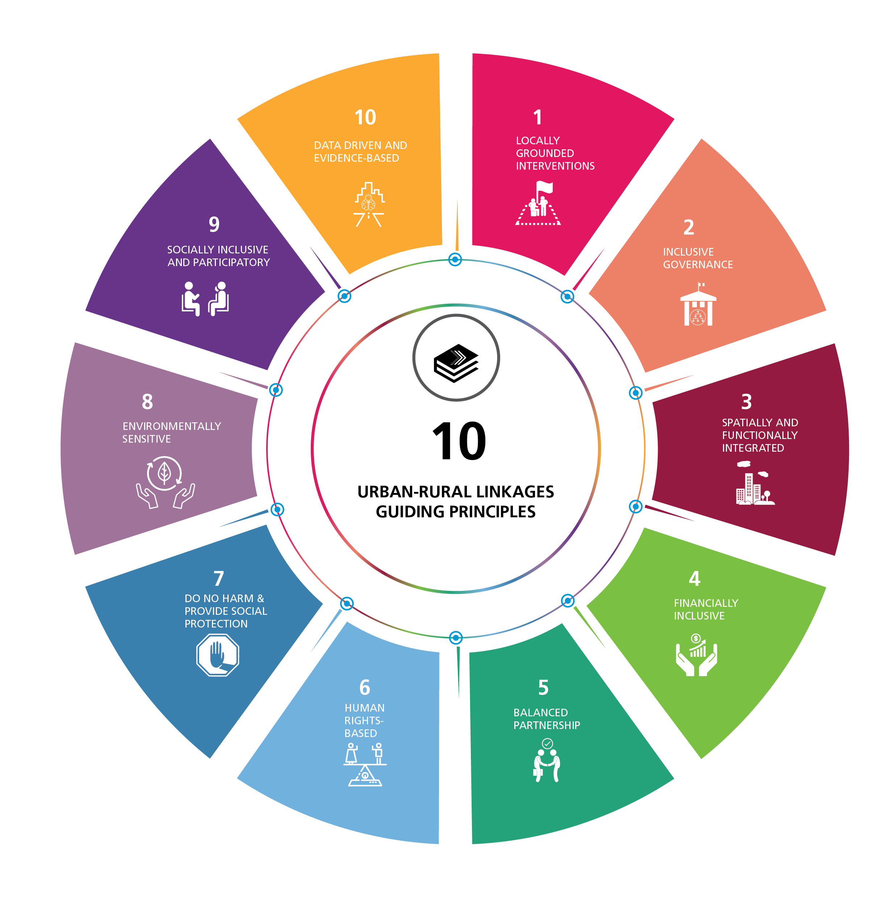
The Guiding Principles provide for flexible application by different levels of government, intergovernmental organizations, development partners and stakeholders from academia, research, civil society including grassroots organizations and the private sector. The Framework for Action addresses measures to create an enabling environment and measures related to eleven sectoral and thematic entry points including:

- Governance, legislation and capacity development: assess capacity and needs for policy tools; enhance dialogue and cooperation across sectors and planning levels and convene new multi-level, multi-sector and multi-actor governance mechanisms and support inclusion of affected urban and rural populations.
- Integrated planning across the urban-rural continuum: Support localization of national planning; integrate urban-rural linkages and integrated territorial development in National Urban Policies and promote networks and associations of planners in different jurisdictions.
- Investment and finance for inclusive urban-rural development: Address and improve public and private finance and access to credit across the urban-rural continuum, focusing on small and intermediate towns and cities and integrated urban-rural territories. Strengthen financial intermediation services and enable ecosystem service provision in peri-urban and rural areas.
- Empower people and communities: Assess and support inclusive multi-actor participatory processes and partnerships; directly address and compensate for inequities across the urban-rural continuum in order to create balance and inclusion from informal and formal sectors.
- Knowledge/data management for dynamic spatial flows of people, products, services and information: Improve collection and management of spatially and gender disaggregated data and knowledge, including ensuring a balance between inclusion of the formal and informal sectors.
- Territorial economic development and employment: Coordinate urban and rural economic development to enhance synergies; harness the potential of small and medium size towns and apply innovations in participatory credit, finance and enterprise incubation schemes to create new jobs that improve territorial flows of products, services and information.
- Coherent approaches to social service provision: Identify needs and opportunities where stronger urban-rural linkages can impact more spatially and socially equitable service provision; pilot new urban-rural partnerships for health and social services outside cities.
- Infrastructure and communications: Perform integrated and inclusive urban-rural infrastructure needs analysis; jointly plan, finance and construct infrastructure for water, sanitation, roads and public transport, electrification and communication, etc.
- Integrated approaches for food security, nutrition, and public health: Mainstream health and well-being by building coherent and linked urban-rural approaches to food, water, energy and health systems with attention to the multiple benefits of the circular economy of the urban-rural nexus, especially when coupled with capacity development and inclusion.
- Environmental impact and natural resource and land management: Conduct strategic environmental assessments to reduce environmental risk from severe flooding, drought, storms, etc.; address land and water tenure and sustainable use of natural resources, protect biodiversity, promote ecosystem-based production systems and build resilient landscapes.
- Conflict and disaster: Assess risks, gaps and vulnerable populations in relation to potential hazards in urban, peri-urban and rural areas; jointly plan for resilience measures and invest across jurisdictions to protect transport, energy, information, health, education, food and water systems, etc.

(UN-HABITAT, 2017)

